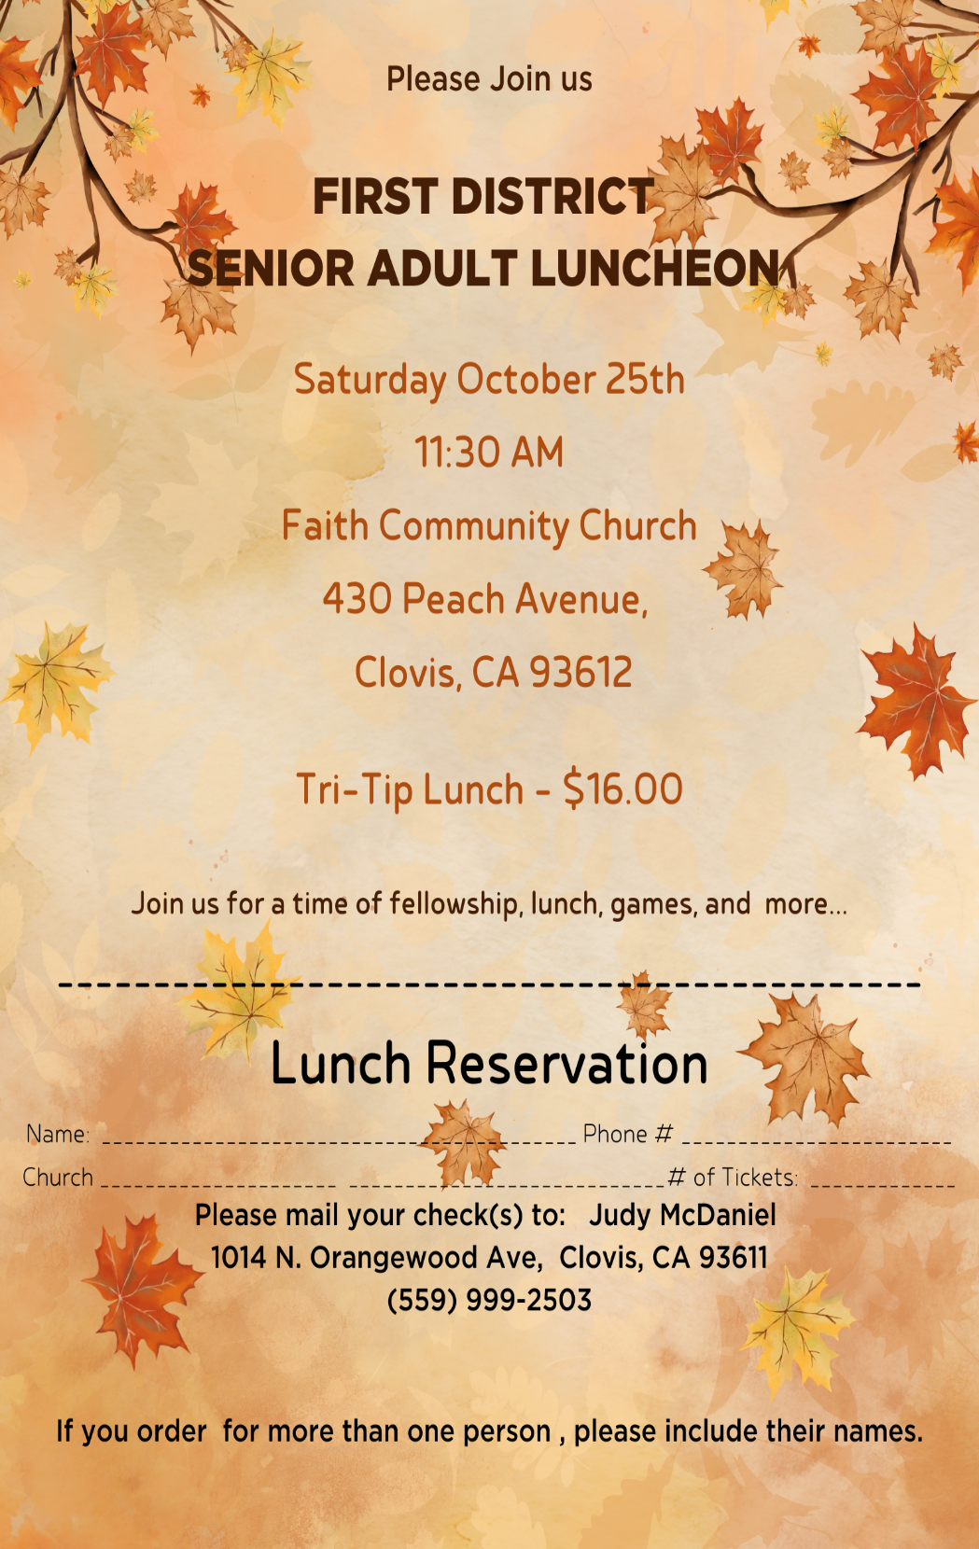 P

Order your tickets by October 19th

Order your tickets by October 19th